Creating a
Parent/Guardian Account on Canvas

What is an observer or guardian account?
In Canvas, the Observer role can be used to enroll parents who would like to participate in a Canvas course but do not need to earn course credit. Observers have limited permissions that allow them to see what is going on in a course without interrupting the flow of daily course communication.
The student must be enrolled in the course and must accept the course invitation before you can sign up to observe the student. If you receive an invalid username or password message during the signup process and the student's credentials are correct, have your student sign in to verify that he or she has received and accepted the course invitation.
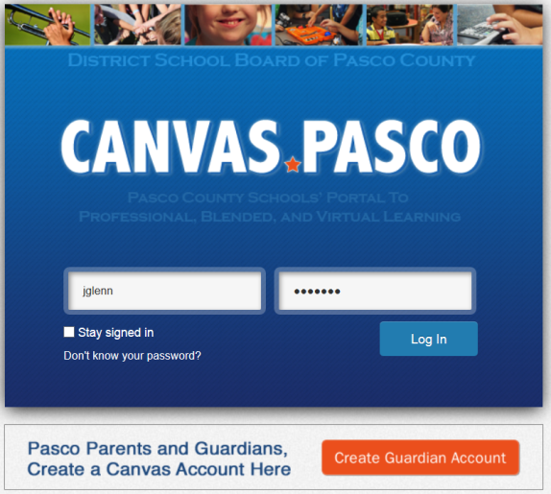
Creating your account:
- Visit http://pasco.instructure.com
- Click the orange button to create a guardian account.

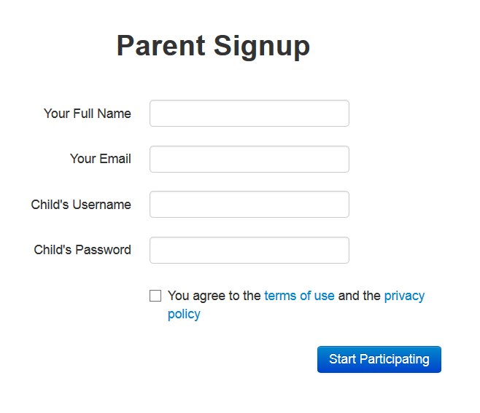
- Complete the brief form to associate your guardian account with your child’s account.

Please note: You will need to have you child’s username and password information, which is issued by the school.

- You will be prompted to authenticate your account via a notification to the email address you have registered. Please check your spam/junk folder if the email does not arrive within a reasonable amount of time.

